How to Do PaPc
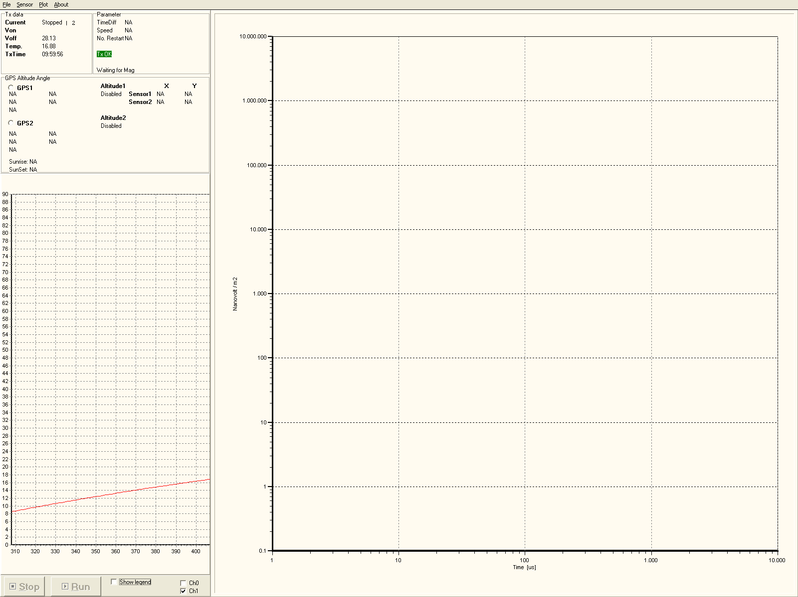

A usermanual on how to handle PaPc program
This is a brief review of how to operate PaPc program. It will try in simple steps to guide you through how you come in and get started in the program.
Link to PaPc
Access to PaPc via remote desktop, you find under accessories. It first needs to be taken hold of the wireless connection. One connector to the access point:
AP: SkyAp
Key: 0102030405
When we first met, you can check this by ping 192.168.1.1. If this goes through has been contact and should not tinker more by wireless. Then check on Monday it has been associated with the PC. This is done by pinging 192.168.1.5 TIBen the address 192.168.1.40 and the blue box is 192.168.1.10. If you have a connection to access the Point and not the PC should reboot the PC. We could be facing that we can not comment on the wireless, there is a good idea to run a repair on this. This rule may solve the problems. You can also just take Linksys USB network card and plugging it in again. This reloads also operates. The latter is only when using external wireless network adapters.
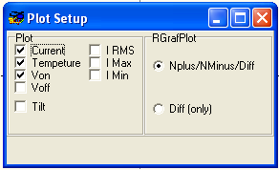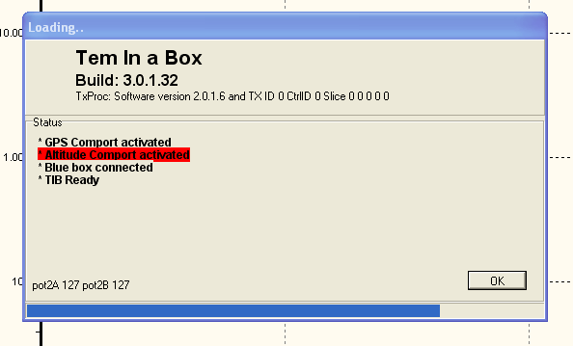.
By booting the following message startip
Here it lists on the boot process. One can see whether there is a connection to the blue box (serial webserver), that GPS is in mm If there is a problem it will be marked in red.
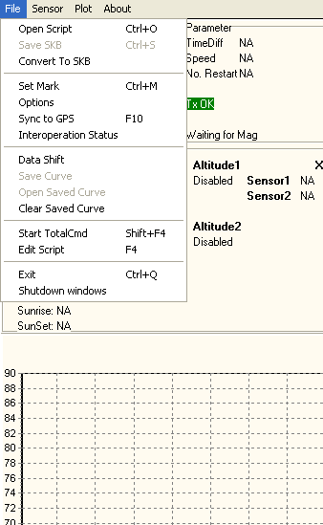Menu:
Normally, we think load into a script. This is done with Ctrl + o or to go up in the file menu and choose Open script. It will then load into the script. When the run is black, you are ready to run. So simple it is to start papcen.
Other things you can do in the file menu will include:
• Convert to SKB: You can select a number råfiler and translate them to SKB.
• Mark Seen: introduce a text file for later.
• Option: start the options dialog (shown later)
• Sync two GPS. Makes an extra sync of tx and papc to gps-time
• Start Totalcmd: Starts totalcmd for copying files, etc.
• Edit script: loader the last script into an editor
• Shutdown windows: close the whole windows down.
Plot Setup:
Here, you're putting the two plot up. You have the opportunity both to get Nplus and Nminus and only diff curves. Additionally, you can determine how much information from TX to be plotttes. Changing the scale of the axes made by pressing on the question.
You choose which channels to plot the bottom of the page
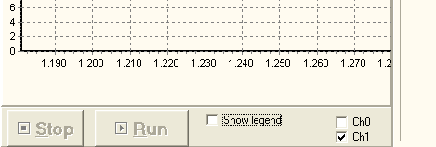

Things you have to check

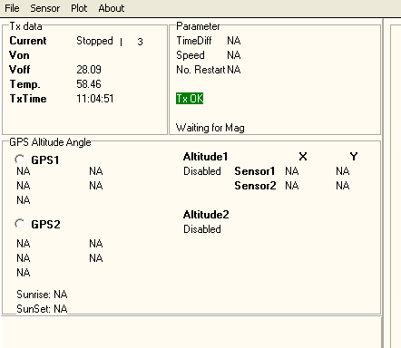
Top looks all data entry. During TX data is everything coming from TX. When you have just started the program will just stand and ask for status. That is to say off voltage and temperature. This will be shown. When the data from YX, the small cursor (1,2,3,4) move, so you can see that it is not the old data. It must move once every second.
Timediff is the difference between the GPS time and PC. This must be very low. You can see the stand and pins. If this happens it is because the one GPS has not been given proper time yet.
No. Restart the number replace have been made.
Then there TX status which should be green. Anything else and there is a mistake.
GPS:
GPSen takes a long time before it comes up. This is because it first needs its almanac (10-30min). But it will say right quick getting GGA but no position. This means that there is a connection and we just have to wait for it to come up with a position.
Altitude:
Increase the frame and check that there is a height
Tilt:
Here are the angle. You must be sure that the correct constants are encoded into.
Sunrise and sun set is designed sun-up and drop on that GPS kordinat. Time is in UTM (like everything else).
TIB (F5):
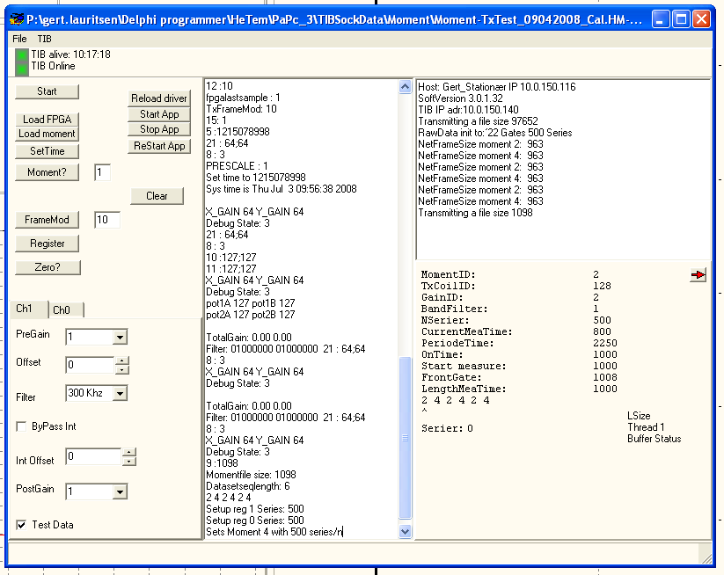
Buttons:
• Start: Start and stop the polls
• Load bin: Loader bin file to the fpga. When the ini-file so that you should only do this once.
• Load factor: loader momemt.ini to TIB
• SetTimer: Author clock in TIB
• Moment?: Lists the moment read out in TIBen
• Register: Register of Lister TIB
• Zero: output an average of 10 samples of the first gate.
• Reload Driver: Copy the new driver from the PC to the TIB and install this.
• Start App: TIB Program Starts in TIB
• Stop App: Stops TIB program in TIB
• Pregain: Inserts gain on the first amplifier
• Offset: Author offset the coil over other amplifier
• Filter: the possibility of setting up a filter in the signal path.
• Bypass int. Turn integrator from. Used to reset the amplifier
• Int offset: author offset the integrator.
• Post Gain: Author gain after integrator.
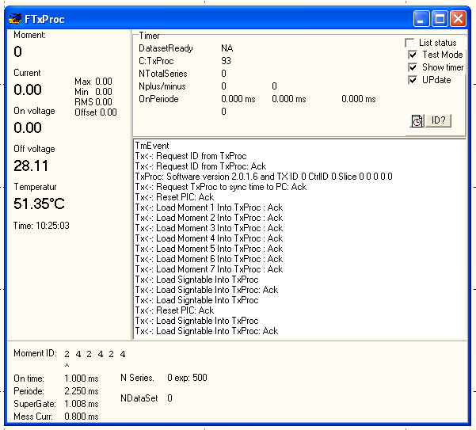TxProc (F8):
Here is the status of the transmitter. It has all the information listed to the left. Besides the obvious, there are two fields there is room to notice.
Max and Min. current.
When we are running a torque will of course be differences in the flow going through the momentum. These differences should preferably not be large. They viewed on my max. If the eksempleen sends arm is on fire, you will have a very small mine, but Max will be normal.
On Off voltage
Tensions at the transmitter are measured both when we send and when not running current. When sending, there will be a voltage drop in must also be. This is seen as forskillen between on and off the tension. It should preferably not be too great. But there can be up to 1V.
Period check.
The transmitter checks the length of all sends pulses, so we are sure there is something gone wrong.
DatasetReady
This is a timer measuring the length to get to the next data set comes from the transmitter.
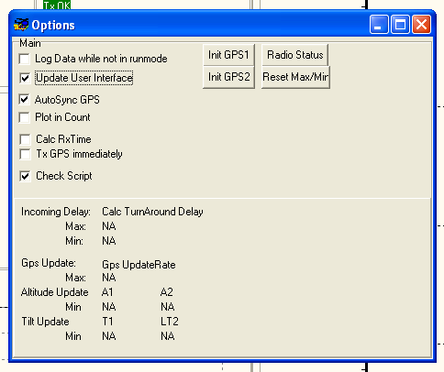Supervision:
Under option is the ability to see refresh rate of all sensors. This could, for example. be that we have had taken a 2 hz altimeter with. Or that the angle is not running correctly. These are labeled Tilt update, and GPS Altitude Update Update.
There are also a few other useful things:
Plot in count: Puts on the plot to show the raw count from the ADC, it is a big advantage if you want to look at the offset and overdrive
Tx GPS immediately: Here sent pitlot info as SNAT is a position from GPS. This allows shorter delay between the current position and it will appear on the map.
Saved curve
You can save and retrieve files into the curve. It saves the curve in an ascii format, as seen below. In the data section, both npulus, nminus and diff for both channels. There is integration table and resettider and gatecentertid. With a little skill will help to restore the curves directly in excel.
That Monday, among other things, can use this to is to put a refkurve into, so that it easier to detect if there is something wrong in the off none.
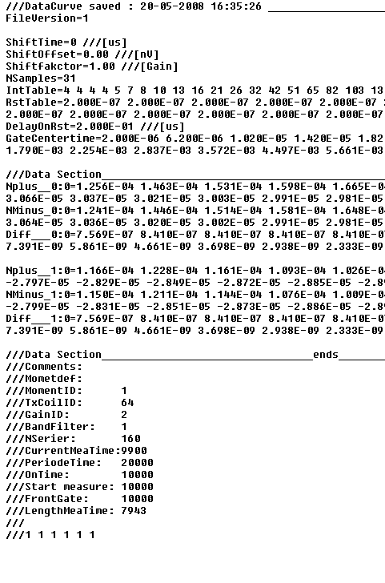
Ini files:
There are two ini files. There is PaPc2.cal where all kalibreringsværdier is in. This can be corrected by the user. Then there papc2.ini, which is the ini file. Here, the program will even write in as long as the program is running. It is not the intention of the user must change in this file. It will be interesting to the user may also change in schedule.
Papc2.cal
/// Calibration Parameters for Inclinations._______________________________________________________
/// To be changed by operator according to applied Sensor No.
CALANG1X = 7.5432 /// Default: = 7.5432 - No. 0515. Insert calibrated value for the actual sensor.
CALANG1OFFSETX = 0.4991 /// Default: = 0.4991 - No. 0515. Insert calibrated value for the actual sensor.
CALANG1Y = 7.5331 /// Default: = 7.5331 - No. 0515. Insert calibrated value for the actual sensor.
CALANG1OFFSETY = 0.5235 /// Default: = 0.5235 - No. 0515. Insert calibrated value for the actual sensor.
CALANG2X = 7.6939 /// Default: = 7.6939 - No. 0516. Insert calibrated value for the actual sensor.
CALANG2OFFSETX = 0.4718 /// Default: = 0.4718 - No. 0516. Insert calibrated value for the actual sensor.
CALANG2Y = 7.5211 /// Default: = 7.5211 - No. 0516. Insert calibrated value for the actual sensor.
CALANG2OFFSETY = 0.5276 /// Default: = 0.5276 - No. 0516. Insert calibrated value for the actual sensor.
/// Control parameters for Mag. Measurements.______________________________________________________
/// To be changed by operator according to Mag. Operation Schedule.
/// Time resolution is 0.6 us up to 38.3 ms.
/// MagOff: = Time interval from TurnOff two Mag. Measure (Falling Edge of Sync. Signal).
/// Magone: = Time Interval where Sync. Signal is on.
/// Magone: 0 = no Sync. The signal is provided.
/// Note! MagOff + Magone <MeasureLength!.
MagData_Moment_0 = 128 /// Magdata for Coil Id: = 128 (Low Torque).
MagData_MagOn_0 = 0 /// [us], No. Sync.Signal Chosen
MagData_MagOff_0 = 0 /// [us]
MagData_Moment_1 = 64 /// Magdata for Coil Id: = 64 (High Torque).
MagData_MagOn_1 = 8000 /// [us]
MagData_MagOff_1 = 200 /// [us]
MagData_Moment_2 = 0 /// Magdata for Coil Id: = 0 (High Noise Moment).
MagData_MagOn_2 = 8000 /// [us]
MagData_MagOff_2 = 200 /// [us]
MagData_Moment_3 = 2 /// Magdata for Coil Id: = 2 (Moment to be chosen)
MagData_MagOn_3 = 2 /// [us]
MagData_MagOff_3 = 2 /// [us]
MagData_Moment_4 = 3 /// Magdata for Coil Id: = 3 (Moment to be chosen)
MagData_MagOn_4 = 3 /// [us]
MagData_MagOff_4 = 3 /// [us]
MagData_Moment_5 = 4 /// Magdata for Coil Id: = 4 (Moment to be chosen)
MagData_MagOn_5 = 4 /// [us]
MagData_MagOff_5 = 4 /// [us]
MagData_Moment_6 = 5 /// Magdata for Coil Id: = 5 (Moment to be chosen)
MagData_MagOn_6 = 5 /// [us]
MagData_MagOff_6 = 5 /// [us]
MagData_Moment_7 = 6 /// Magdata for Coil Id: = 6 (Moment to be chosen)
MagData_MagOn_7 = 6 /// [us]
MagData_MagOff_7 = 6 /// [us]
/// MUST NOT BE CHANGED ########################################### ###############################
/// Calibration Parameters for Current, Voltage and Tempereture.
/// NOTE! Must not be changed!
CALFAKTORCURRENT = 0.03104
CALFAKTORVOLTAGE = 0.02144
CALFAKTORTEMPETUR = 35714 / / New value from build 33
CALOFFSETCURRENT = 0
CALOFFSETVOLTAGE = 0
CALOFFSETTEMPETUR = 0.25
PaPc2.ini
PaPcId = 22
This is PaPcen ID, this number will be included in the data file
TIBIP = 192.168.1.40
This is TIB's IP address. PaPc start to look for TIB, therefore, the knowledge of what must address the search. In the beginning you can see that it says on the TIB is offline or online. It is whether you can ping this address
PingCom1 = 192.168.1.10
There is a serial of papcen server which we call the blue box, because it is blue. This is a IPadresse. PaPc'en will ping this address to check that it is there.
Hostip = default
When the TIB should contact PaPcen be the "poor" into an IP number, if you put the default here, will TIBen tag the address Papcen can see it. This is usually the right one if you have multiple network cards in a PaPc there may be a problem about which address the need to select.
MagIp = 127.0.0.1
To send data MagPc can Pilot be starting a server receiving such data. If you put this to 0, this function will be disable
Moment_file = C: \ TIB \ Moment \ Sweden_HighMoment_20080422.ini
This is the name of the last loaded script file. This will come up when you load a new one. So if you just press Ctrl + O enter the loader Monday the same again.
FPGA_Bin = c: \ TIB \ WEB \ tib_p1.bin
This is the configuration file to FPGAen in TIBen. This will automatically be loaded down during the boot
DATADIR = c: \ TIB \ Data \
This data will be saved.
TXCOMNR = 38 /// Default: = TX comporte No. 38.
ALT1COMNR = 33 /// Default: = 33 Altimeter Unit no.1 comporte No.
ALT2COMNR = 34 /// Default: = 34 Altimeter Unit no.2 comporte No.
GPS1COMNR = 36 /// Default: = 36 GPS Unit no. Comporte No. 1.
GPS2COMNR = 37 /// Default: = 37 GPS Unit no. Comporte No. 2.
ANGCOMNR = 32 /// Default: = inclination comporte No. 32.
RadioCOMNR = 35 /// Default: = 35 Radio comporte No.
This hunch is above comportnummer on the equipment Papcen handle.
So there will be a part of how we set up GPS:
GPS1BaudRate and GPS2BaudRate = 9600 = 9600
This is the baud rate respectively GPS1 and 2nd
GPS1TYPE = NOVA and NOVA GPS2TYPE =
This is the establishment of DGPS file. In this, everything from GPSerne and used to process mail of the location. If there is NOVA come this file is not.
GPSTIMEOUT = 2000 /// timeout Wednesday GPS
GPSen must give a signal within the time otherwise there will be a mistake
So is there anything to put altitudes up:
ALT1BaudRate = 9600 /// Default: = 9600
ALT2BaudRate = 9600 /// Default: = 9600
ALTTIMEOUT = 2000 /// Timeout on altitude
This is the setup of altitude 1 and 2, but their baud rate and time
Then we have a part to put up TIB:
Auto Connect = 5 /// [sec.] Time interval from first active Ping of TIB two StartUp TIB.
When you turn the TIB must take some of you come through in the first ping to that one begins to login.
PosPot0 =- 4 -13 ///:= Preamp Offset, Integrator Offset for çH0.
PosPot1 = 2 -5 preamp ///:= Offset, Integrator Offset for CH1.
Configuring offset the integrator and preamp. This is not a value be changed manually.
FPGA_DataSort = 1
Various options for index ring. 0 Indexing in SoftWare, 1 Indexing in hardware. So far, only hardware index
GainX = 64 GainY = 64
///:= Pp-rr-ss-tt (bytes), pp = Bypass, rr = PostAmp_index, ss = Filter_index, tt = PreAmp_index
/// PP: = 01-No Bypass
/// rr: = 00-x1, x2, 01, 10-x4, 11-x8
/// ss: = 00-300kHz, 01-100kHz, 10-30kHz, 11-10kHz
/// tt: = 00-x1, x2, 01, 10-x4, 11-x8
DebugState = 0
We have the opportunity to get FPGA to create "tælletal"
Default: = 0 Analog on both channels: = 1 TestSequence on çH0,: = 2 TestSequence on
Ch1,: = 3 TestSequences on both channels
FrameModCount = 10
Default max. number of series per frame
ScaleByInttable = 1
1 Adjust gate values according to gate length.
TxProc_top = 179
Top Position of F8 Dialogue
TxProc_left = 919
Left Position of F8 Dialogue
TiB_top = 299
Top Postition of F5 Dialogue
TiB_Left = 565
Left Position of F5 Dialogue
Graf2Do = 7
Plot type of dB / dt plotting
Plot Chan = 0
: = 0 Plot Cho,: = 1 Plot CH1.
Plot2Do = 7
Plot type TX Parameter Plot THINGS
Plot_AutoScale = 0
This is the plot of the data will auto scale on the left axis
PlotMax = 120 /// TX Plot Max.
PlotMin = 0
If you have not set up auto scale to, which is usually not, this is my max and on the axes.
PlotLength = 100
The length of the plot for TX data. The abandonment of the samples. There are normally per sample. sec as it is about 100sec far
MinSpeed = 10
HMinFaktor = 0.7
HMin = 10
HMax = 20
Max and my height of the emergency, not currently used, they are included here because they once were used
Angle2Show = 1
Default: = 1 Unit Adr. inclination of two Pilot Display.
FRAME TIMEOUT = 1000
Sometimes a frame from TX to be completed in
TXPROC_TIMEOUT = 1000
The time which Papcen has sent a ghost is out and that there must be an answer
DISPLAYTIMER_PILOT = 1000
The time lag between the data being sent to the pilot, if you do not have
ITXPROCFRAME = 1000 /// Timeout on a frame from txproc to complete
When sending a frame starts with the data it sends a start-up nature, this is the time of this happening until frame must be finished
ITXPROCDEFTIME = 500 /// TXproc timed Wednesday's response from PC
If the transmitter will be prompted a response, then the answer must come within this time
ITXPROCMAXRETRANS = 5 /// Number of hours the TX wil retransmit
The number of retransmitioner of data to the transmitter.
OH_Faktor = 3 /// over head on time on a datseqset
PaPcen star and keeping an eye on that dataset (flows) from the transmitter. This is calculated from the length of moments. This time multiplied so with OH_faktor before there comes a time
AngleInterval = 500 /// [ms] - Sample density of inclination data
Sample range of angle
PeriodeCheckMax = 100 /// [us] - Max. Timediff. Wednesday TX Period check.
The transmitter checker always onperioden of txsignalet. If it is not within the time + periodecheckemax, then we will restart.
UpPilotDispASP = 1
Sending data to the pilot as soon as data from GPS
WalkTemVersion = 1
Removes all information is not interessate on an instrument walktem
AlwaysSkb = 0
Laver SKB file each time you press the stop
ShowCPULoad = 1
Shows CPU load at the bottom of a bar, and logs in the event file
UpRampeTimeStamp = 0
Calculate TX data, if these are temporary temple on the first upramp, instead of when data is being sent, as is the norm.
MaxGpsTimediff = 1
Check in time from the GPS does not differ too much from the PC time
PilotBinMode = 1
Ability to send data to the pilot in binary form
Supervisor Mode = 0 /// Supervisor disable mode when the program close
If you want change in the configuration of TIB, the supervisor mode set. Acting from the build 3.0.1.37
FAQ:
There are various data and communications routes in the system:
1) TIB <over fiber> PaPC:
Communication between TIB and PaPC. It is about downloading code from PaPC to TIB, parameter setting of the PaPC TIB and data transfer from TIB to PaPC.
2) TIB> over fiber> PaPC> TX:
Sync signal from the TIB, through fiber connection to PAPC, where this is converted into electrical signal and passed on to TX
3) PaPC <> TX:
Communication between PaPC and TX. It is about downloading files and moment to moment settlement TX from PaPC and upload of control and data flows / tension / temperature for PaCP from TX
Important:
It is important, before starting its survey to have updated its Backup Library, so the files found there is the same as used in surveys and can be used directly for replacement if the files corruption.
Checks:
Check Fiber Connection:
Fiber Connection may not contain sharp bends, tensile stress at plugs or other mechanical stress of the cable. The plug must be completely screwed in and not with "violence". The optical fiber may not have bends in less than 10 cm in diameter.
Check TIB battery:
Goal battery power (12.5 Volt or more) or switch to a fully charged battery.
Cold Start TIB:
It turns off the power to the TIB and switched on again.
Cold Start PaPC:
PaPC closed as far as possible down and the power connector is removed. Remember to remove Backup Power jack suit. Then turn on the power again and Backup Power plug into the Power Backup desired.
Restart PaPC:
Task Manager is chosen and restart the PC elected.
Restart PaPC program:
PaPC program shuts down, either generally or with a Task Manager and start up again.
Ping command:
....................................
Cold Start TX:
High power plug taken out of TX, counted to 10 and put it in again.
Here just a collection of possible errors and what you do.
During the inauguration of PaPC program reported TIB Offline, even after trials in which PaPC program has been closed and TIB have been cold started.
Problem in kommunikationsvej 1) and its components.
Close PaPC program down.
Ping 192.168.1.40, which is TIB's IP address. If there is contact here, then????
Otherwise:
Check battery and fiber connection between TIB and PaPC.
If there is connected new TIB without PaPC residue is terrific to be TIB cold start and PaPC restart.
If there are no errors or the system does not help changing:
1) Fiber Cable and test.
2) TIB and testing.
3) PaPC and testing.
If no replacement of TIB + Fiber + PaPC helps contacted .....
You can not have contact with PaPC over the wireless network ....
First:
Ping Blue Box: Ping 192.168.1.10. This is the IP address for Blue Box. If this does not reply'er is probably not turned on for PaPC'en.
Reply from the Blue Box, so cold start PaPC'en.
If this does not help, turn PaPC.
SkyAp is no more among the wireless network, but there is a Linksys instead.
Access Point has resat to default. Try first to take power from and see if it comes right up. If it still has not come up, so set netwærkskabel in. Start a browser's address 192.168.1.1. You asked for the password: admin password admin.
Now up to the wireless SSID = SkyAp and with WEP encryption 0102030405
If one just after the start of PaPC program comes malfunctions that were not listed second site, so ...
Restart PaPC program.
If this does not help, then restart and re PaPC program PaPC.
If this does not help, then upload Moment library, WEB library, PaPC2.exe and PaPC2.ini from backup directory and restart the program.
PaPC program run by an elected moment.ini file, but the flows are 0
The program is running will say that the current view, running 1, 2, 3, 4, 1, 2, ... as torque switch. Is likely due to errors in kommunikationsvej 3) and its components.
There is a lack of sync signal.
Cold Start TIB and restart PaPC.
Check Fiber Connection.
If the error is no replacement:
1) Fiber Connection and test ..
2) TIB and testing.
3) PaPC and testing.
4) TX and EAF cable and test.
If not this helps contacted .....
PaPC program runs with a display of current, but there appears no plot .. Check that çH0 and ch1 are winged by.
PaPC program "locks" after you have loaded the file and moment.ini pressure RUN
It will be necessary to stop PaPC program with Task MANAGER. Here, we must be patient because this may take time ...
The correct handling of PaPC program is to download the file and moment.ini wait for CPU load is stabilized, then press RUN
It is not always that everything just in time to be cleared completely of, so there may well be the processor in the process of indloadningen of the script, although it has reported RUN. Therefore, it is a good idea to just take it calmly.
The GPS shows no data, it takes 15 minutes before GPSen are up after the power is taken. Hold on
While starting PaPC program pops a form with: "TIB Application is already running"?? TIB cold start and PaPC program is restarted.
TIBen contains a small PC, which is a program that is up and running. This is normally shut down along with papc surface. But if you do not close it down properly, there will be no message to the TIB to stop.
PaPC program restarts regularly or even often ... Check in the restart log what the reason is:
1) Most FrameErr. Errors in kommunikationsvej 1) and its components.
Check Fiber.
Change Fiber and test
Change TIB and test
Change PaPC and test
If it does not help, contact ...
2) Most SerieErr. Errors in kommunikationsvej 1) and its components.
Change TIB and test
Change PaPC and test
Change Fiber and testing.
If this does not help, contact ...
3) Most TX Stop
! It should be in the restart log on the period errors or other mistakes information ...
I do not know if we should make more of those errors. They are right essensielle.???
By sending field in PaPC form is not a "green" area with TXOk but a red box with .....
Check REF cable between PaPC and TX.
Cold Start TX and restart PaPC program.
If this does not help, so close PaPC program that copies PaPC2.exe and PaPC2.ini from backup and restart PaPC program.
If this does not help, then replace TX.
If this does not help, contact ....
The transmitter can midst connection either by mistake or on cable that ends in a state where the program just can not get out of.
PaPC program is running, but there is no power at HM / LM See F8 interface that runs moments.
If not, then cold start TX and restart PaPC program (is this possible error?).
Helps this is not, then shift TX.
The connection within the TX can smoke, which would mean that sends the banks are not being managed. It may also be where a block is on fire.
GPS says you have to check cable GPS sends nothing, therefore it is defective
GPS says getting GGA but no GPS location data to send Papc, so there is connection. Wait to get the almanac

